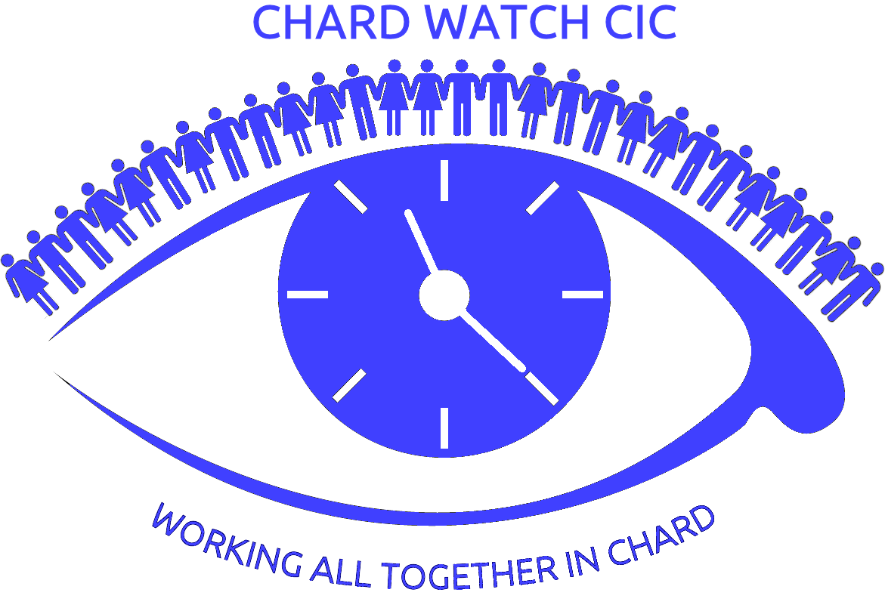
CHARD WATCH CIC
(WORKING ALL TOGETHER IN CHARD)
Your potential. Your voice. Your way

WATCH CIC working in partnership with
Somerset Skills & Learning

Learning Peer Support Course

Have you experienced barriers to learning in the past?
Would you like to know more about the value of
Peer Support?
If so, attending this course with like-minded people and being part of a supportive group, you will learn together how to access and participate in local learning activities and opportunities, as well gaining new tools and skills.

The course is FREE to adults who wish to support their mental wellbeing by engaging in learning

Course Dates: Thursday 18th, 25th January and 8th, 15th February 2018
Venue: St James Church Hall, St James Street, Taunton TA1 1JS
Times: 1.00 pm to 3.30pm
Tutors: Rosie Masters and Alice Smith

Course Content
Understand the value of peer support
Learn tools to enable active participation in learning activities that support self management and recovery from mental health conditions
Recognise the benefits in peer support learning activities:- reducing feelings of isolation, improving confidence and independence, milestone setting, progression & achievement, moving on into further learning, voluntary work and job prospects.
We will explore Principles of Peer support and:-
- Barriers to Change
- New Ways of Learning
- Mutuality
- Equality and Diversity
- Boundaries
How to form and maintain a Learning Peer Support group in your local community and progress to mentoring /supporting your peers.
To build confidence in working to your overall goals, in your own way.

To apply complete the attached Booking Form or contact Ruth by e-mail ruthcrooks.watchproject@gmail.com or phone Ruth on 07472756203

Free places will be allocated on first come first served basis, so book now

CHARD WATCH CIC
(WORKING ALL TOGETHER IN CHARD)
Your potential. Your voice. Your way.

Booking Form
We would like people who are interested in the Learning Peer Support Course to complete this booking form. The form is for the purpose of making contact with you as the course approaches, to provide you with more course attendance details and confirm you still wish to attend.
Name
Contact numbers
Email Address
Postal Address
How would you prefer to be contacted? (please circle)
Phone call Text Letter Email
Which course location are you interested in attending? (please circle)
Taunton Ilminster Crewkerne
Do you have any additional support needs we need to be aware of?

Return via e-mail to ruthcrooks.watchproject@gmail.com or post to
Chard WATCH CIC, Forefront Community Centre, 42 Fore Street, Chard, TA20 1QA

