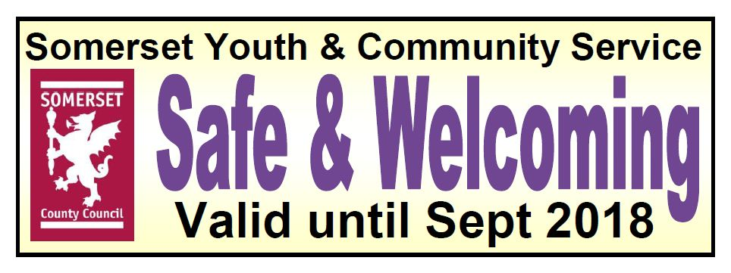
<Your youth club logo>

Your S&W Logo here

Be safe at <Name of club> Youth Club!

We want you to be safe
in our youth club

To help sure you are safe here:
- We will let you and your parents or carers know what we’re doing
- We will always keep to the rules that make you safe
- We will train our staff and volunteers to make sure you are safe
- We will always listen to you as your views and feelings matter

These are the people who will make sure the club is safe. Talk to them if you are worried about anything or have any questions.
<Place photo here>  <Print Name>  What they do (role) |  | <Place photo here>  <Print Name>  What they do (role)

