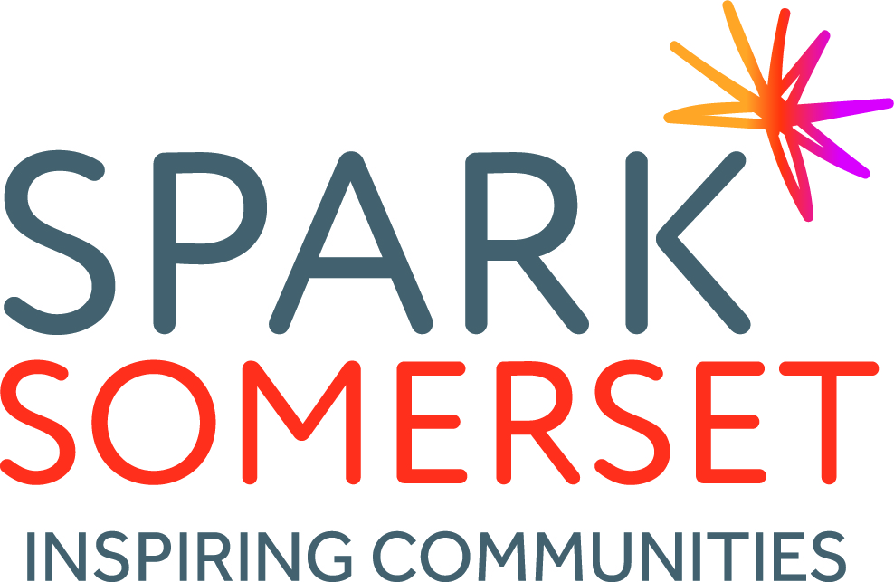

Spark Somerset is a thriving and dynamic infrastructure charity, providing vital support and training for the voluntary sector across the County.
With the vast majority of community groups in Somerset considered ‘small’ or ‘micro’ and 67% of these groups being run entirely by volunteers, we provide a ‘listening ear’, practical support and expert guidance.
Charities and voluntary groups form the backbone of many of our communities, but it is a sector under enormous pressure, caught between reducing resources and a growing demand for their services. Therefore, in this environment, the support provided by Spark Somerset is needed more than ever.

WHAT WE DO
Support for voluntary and community groups
- Setting up, governance
- Funding advice, Business planning
- Support via our website, social media and also through our weekly e-bulletin
- Volunteer management, recruitment and retention
- Training
- DBS checking service
- Community Accountancy Service
Spark Volunteer Service
We run a volunteering brokerage service across three Districts of Somerset. We engage with local communities to improve the quantity, quality and diversity of volunteering, matching individuals to a cause that matters to them. We also promote the value of volunteering and social action and work with local partners to ensure that it can flourish.
As well as supporting individuals to take part in social action, we encourage volunteering good practice amongst the groups with whom we work, providing guidance, support and training.
Voice of the sector
The Spark Somerset team represent the voluntary sector in a range of different forums, including these examples below:
- Somerset VCSE Strategic Advisory Group
- Neighbourhoods Group
- Regional Volunteering Board
- SST Strategy Group
As a key infrastructure organisation in Somerset, we represent the local voluntary sector at community, District, County and Regional level. We also listen to the needs of the local sector so that we can shape and develop the support we provide accordingly.
Health and Wellbeing Project
Health and Wellbeing Project in South Somerset, which facilitates links between health and local communities. Also includes the coordination of the Community Ambassador Volunteer Network, training for Community Connectors and coordination of a Directory of community-based services that support health and wellbeing: www.wellbeingsouthsomerset.org

OUR VISION, MISSION & VALUES

Vision
Voluntary action is thriving and effective in helping the people of Somerset to be healthy and engaged in their communities

Mission
SPARK is established to provide high quality support to voluntary and community sector organisations through direct provision of services

Values
SPARK is passionate about voluntary and community services that make a difference. We are committed to supporting other local voluntary sector organisations and where appropriate to provide services ourselves to achieve this.

Our dedicated staff and volunteers are pro-active and resourceful in seeking out solutions to challenges and act with integrity, always maintain a focus achieving benefit for those we serve. We pride ourselves in offering value to our beneficiaries through cost effective support that is both accessible and inclusive.

We seek to be:
Efficient, professional, business-like, approachable, responsive, knowledgeable, experienced, creative, empowering

OUR HISTORY
Spark Somerset, in its current form, was registered as a Charitable Incorporated Organisation at the end of 2018. However, the work of Spark has existed for many years prior to that, as part of a separate charity, South Somerset Association for Voluntary and Community Action, which has been in existence for more than 30 years.

In April 2016, South Somerset Association for Voluntary Action (SSVCA) took over the operations of Mendip Community Support (MCS) – and the core function of the charity was rebranded as Spark.
Spark now offered guidance and support to groups and provided a volunteer brokerage service across Sedgemoor, Mendip and South Somerset.
In 2016-2017, Spark continued to grow considerably. In previous years, our work was mainly funded by South Somerset District Council. However, the charity began to attract significant funding from elsewhere: Mendip District Council, Sedgemoor District Council, Somerset County Council, The NHS Symphony Programme, Somerset Community Foundation, Yeovil District Hospital and Yarlington. We have also sought to generate income through additional provision and have secured a small regular income stream through our DBS checking service, community accountancy, training and paid-for consultancy work.

In January 2018, the SSVCA Board of Trustees made the decision that Spark should move to become a new CIO. This is due to a number of compelling factors including brand clarity, governance issues, VAT and sustainability.

Based in our new home at Monks Yard, we now begin a new chapter, with an energized Board, growing team and exciting plans for the future.

