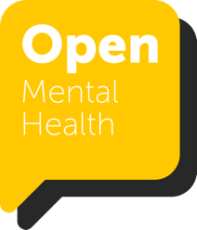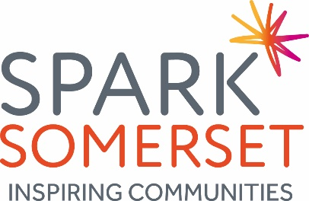

Job Description

Job title | Volunteering Project Co-ordinator – Open Mental Health
Working hours | 37.5 per week with flexible working by agreement
Annual Salary | £24,000
Accountable to | Volunteering Development Manager
Term of Contract | 12-month fixed term contract, with an option to if funding is available
Annual Leave | 24 days pro rata + bank holidays
Probationary Period | 3 months
Office / Home base | Home-based (Flexible)
Expenses | Travel expenses from home

Purpose of Role

Spark Somerset is a proud member of Open Mental Health, an alliance of local voluntary organisations and the NHS. We are working in partnership to ensure that residents of Somerset get the support they need, when they need it.
Lots of things can impact our mental health. We have come together to provide 24/7 support to adults in Somerset. Whatever the worry - anxiety, debt, employment, housing, low mood, addiction - we're here to help. Open Mental Health supports people to live a full life by enabling access to specialist mental health support, debt and employment advice, volunteering opportunities, community activities and exercise.

Working as part of the Spark Somerset Volunteering team, and with partners of the Somerset Mental Health Alliance, the postholder will support the coordination of a joined-up approach across Somerset. They will work with partners to develop a consistent approach to volunteering, providing support around recruitment, training, management and supervision. The post-holder will also work with Alliance partners and the Spark Somerset volunteering team to develop meaningful volunteering opportunities that will impact positively on peoples’ lives. The outcomes will be that more people gain opportunities to contribute their time to causes they believe in, and build their self-esteem, resilience and employability where appropriate. Through this our focus is on improving mental well-being and recovery.

Responsibilities

- Lead on the development and coordination of the project, with support from the wider Spark Somerset Volunteering team and Somerset Mental Health Alliance.

- Identify and build relationships with potential partners and stakeholders with a shared interest in the success of this project

- Support the recruitment, training and management of volunteers across the Open Mental Health service.

- Plan communications and manage the recruitment of volunteers to act as volunteer peer supporters and mentors for people with mental health difficulties and establish ways of matching mentors to volunteers

- Work with partners to redesign (where appropriate) and support access to training, DBS checks, induction and management with the aim of establishing common processes and procedures around volunteer management.

- Consider and implement ways of assessing and meeting the support needs of volunteers and support learning and insight to better tailor the project around people’s needs as it progresses. This will contribute to the development of a peer support framework.

- Research and prepare guidance for organisations working with supported volunteers, help to promote opportunities using Spark a Change and other means and

- Provide regular check-ins with supported volunteers to ensure their needs are being met

- Work to observe and promote the identified culture shift for the whole system Somerset Mental Health Alliance and work within the policies and procedures of Spark Somerset including equalities, health and safety and data protection.

- Develop a bank of case studies and other relevant data which demonstrate the impact of our work and keep insightful records of work undertaken

- Provide written or verbal reports, or make presentations as agreed to share and reflect on the project and its achievements and learning

GENERAL

- Undertake any other duties that may be reasonably required by the Manager and the Board.

- Ensure that the values of the Spark Somerset and the Mental Health Alliance are always promoted.

- Promote and adhere to all policies adopted by the Board of Trustees.

Person Specification

Supported Volunteering Coordinator

CATEGORY | REQUIREMENTS | ESSENTIAL/  DESIRABLE
Education/  training | Good level of education. 5+ GCSEs A-C.  A level or BTEC or similar in a relevant area or a relevant degree  Safeguarding, Mental Health awareness, GDPR training | E  D  D
Experience | Experience of volunteering (or similar) and at least 2 years' experience of supporting people with mental health difficulties (as an employee or volunteer)  Experience of team leading or managing volunteers  Track record of working to and achieving deadlines and targets | E  D  E
Knowledge | Understanding and knowledge of the value of volunteering particularly in relation to mental health and resilience  Understanding and knowledge of mental health and how it can affect people’s ability to engage with their communities. | E  E
Skills/  Abilities | Excellent oral and written presentation and communication skills which are clear, easily understood and relevant to a range of audiences  Ability to manage time and prioritise workload  Relevant ICT skills to support project work and document management, eg use of MS Office suite, social media  Empathy, negotiation and listening skills  Able to work both under own initiative and with the flexibility required to collaborate with the wider team  Creative, lateral thinker | E  E  E  E  E  E
Travel / Working  hours | Ability to travel according to the needs of the job with reasonable adjustments if required, according to the Disability Discrimination Act  Ability to work flexible hours including evenings and occasional weekends | E  E
Equalities | Commitment to anti-discriminatory practice and to implement the Equal Opportunities policy of Spark. | E
Physical | Able to carry out the duties of the post with reasonable adjustments where necessary | E

